Homework Assignment 3

Zach Kushnir - 4367785

1- Logistic Regression

1. Size:

X = 100x3

Y = 100x1

1. Plot:

ps3-1-b.png

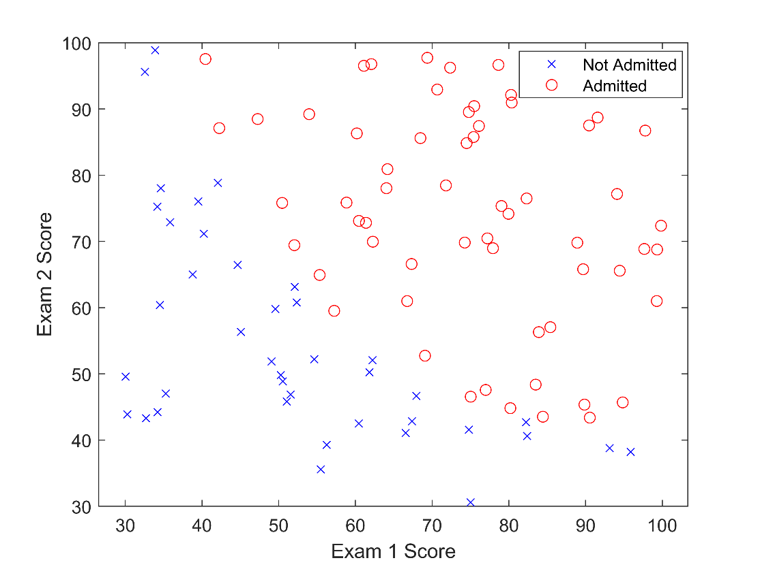

1. MATLAB Code
2. Based on the plot, the value of g(z) reaches .9 when z is about 2.3.

ps3-1-d.png

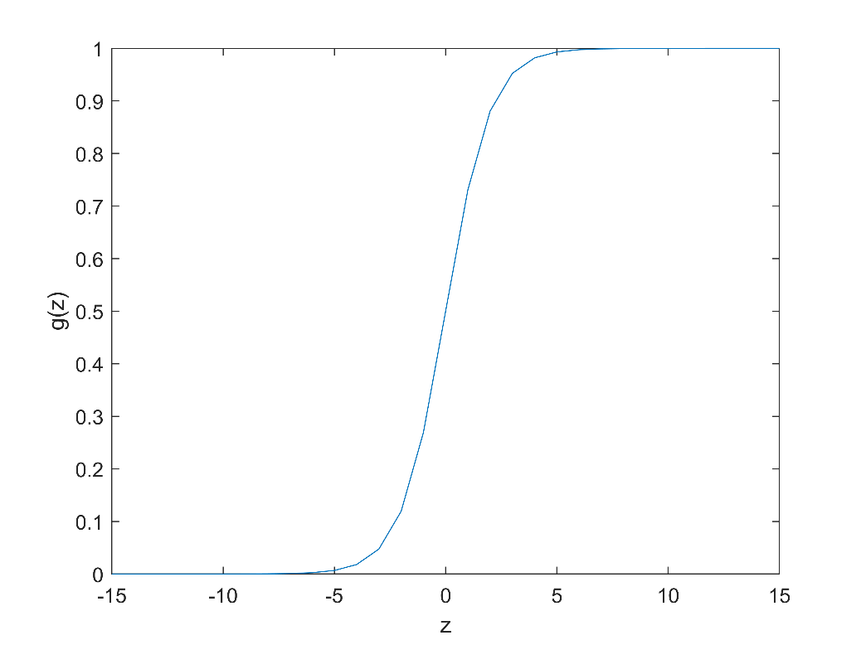

1. Cost: 1.1269
2. Theta = [-25.0756, 0.2059, 0.1971]’ , Cost = 0.2069
3. Plot:

ps3-1-g.png

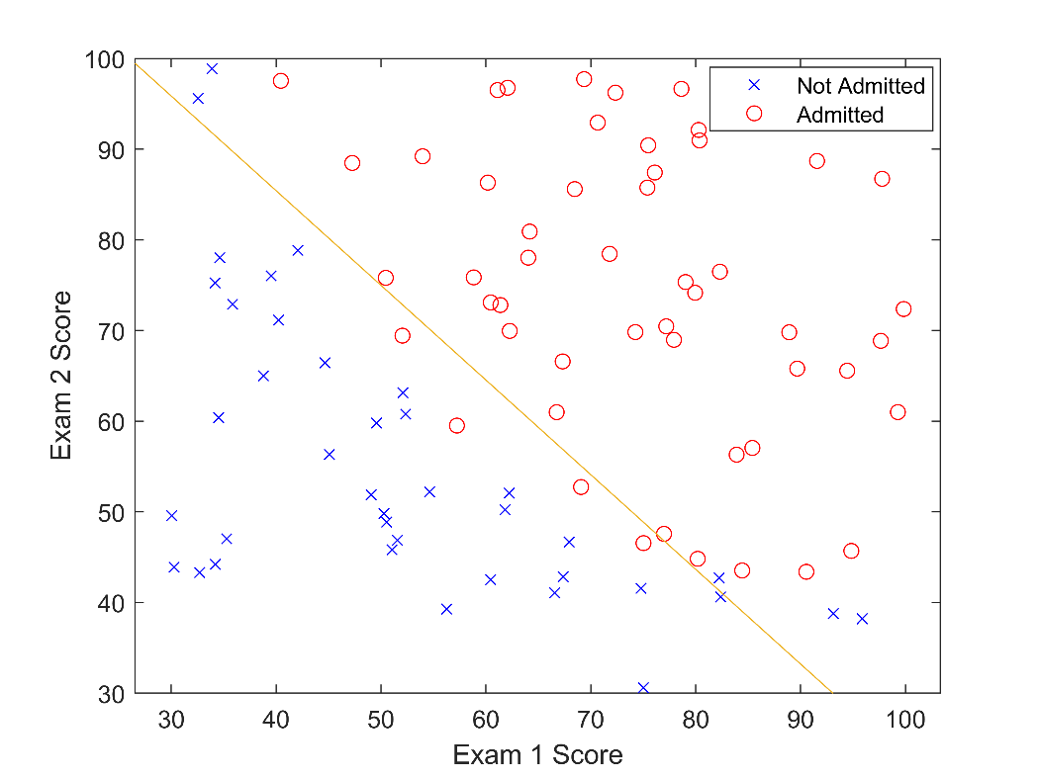

1. Accuracy = 0.9
2. The admission probability is 0.5443. Based on the probability, the admission decision should be admitted.
3. Bonus

2- Non-linear Fitting

1. Theta =

1.0e+05 \*

2.1926

-0.0078

0.0001

1. Plot:

ps3-2-b.png

